OJT Weekly Report and DTR Monitoring System
Module Plan, Network Infrastructure Plan, and Test Plan

1. Modules and Features

1.1 Module map
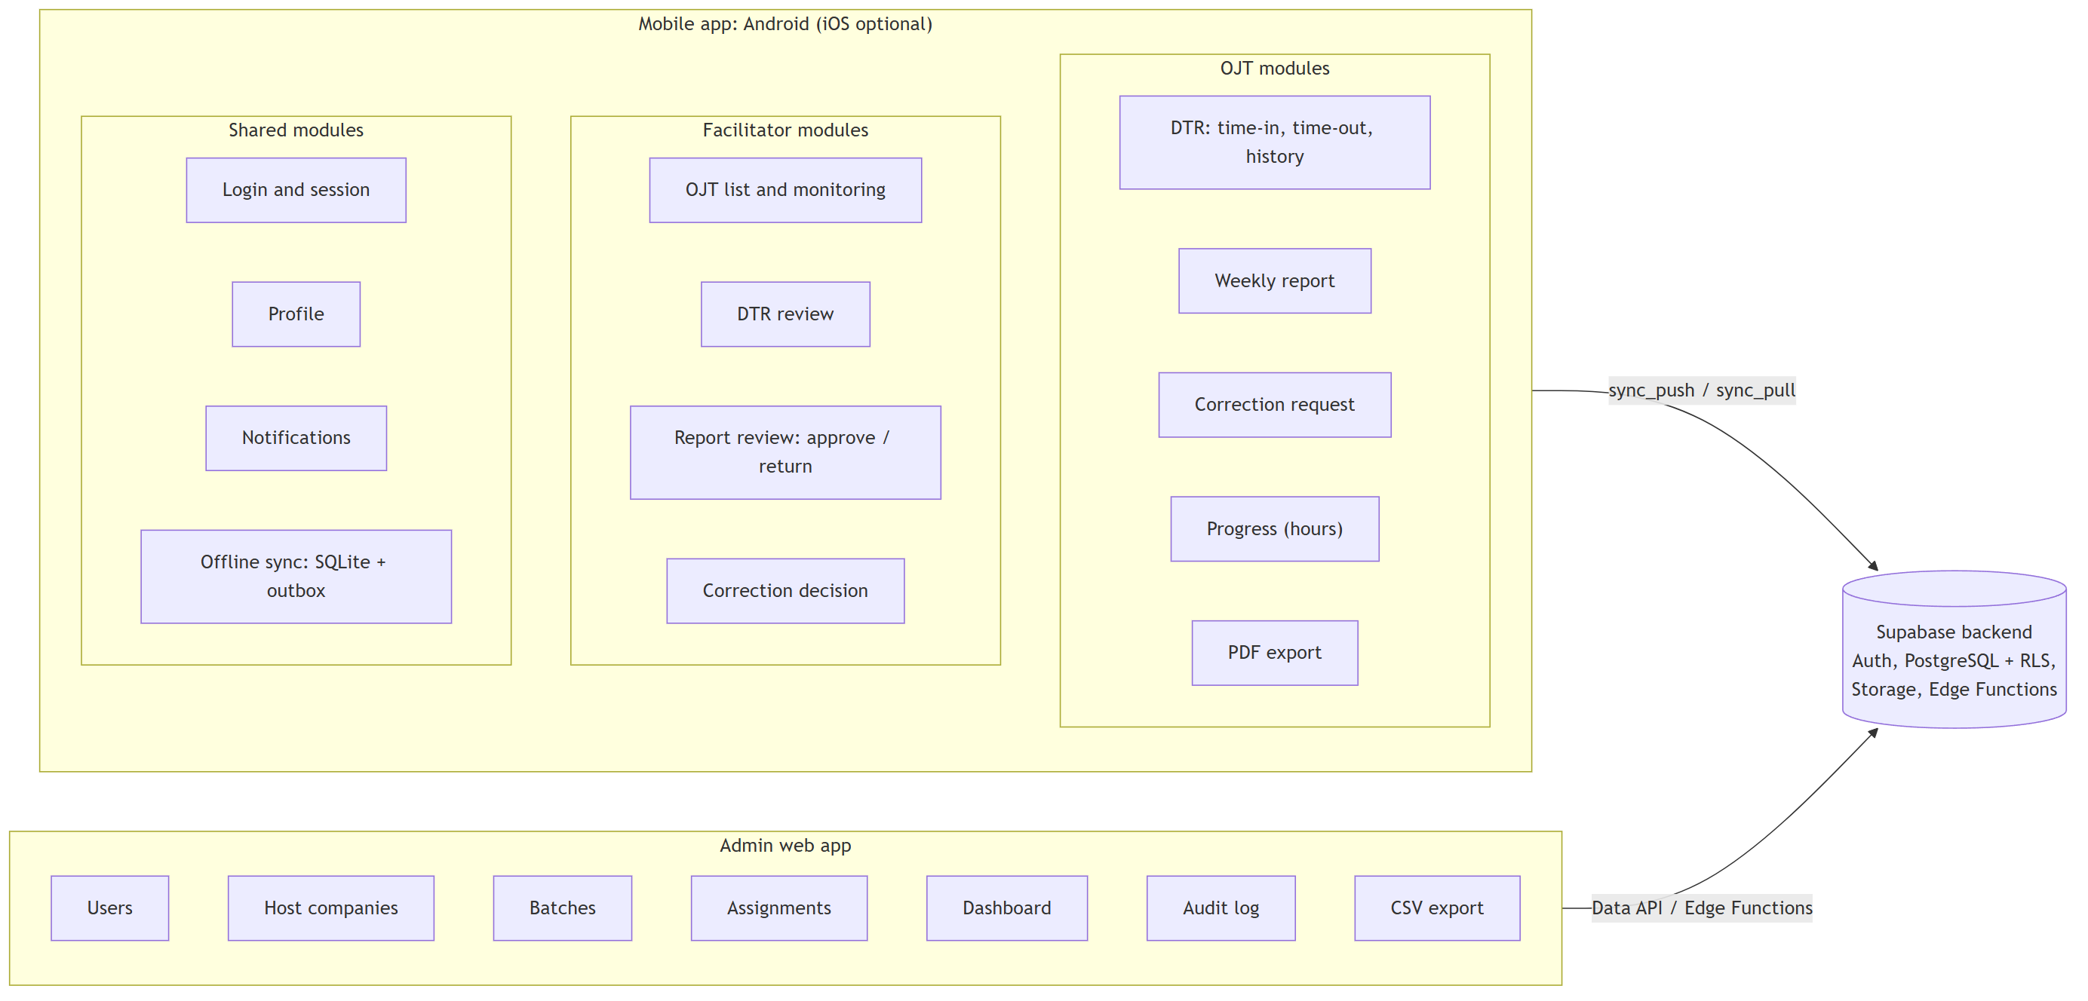
Figure 1. Modules for each role and platform

1.2 Module list
Code | Module | Main features | OJT | Facilitator | Admin | Offline
AUTH | Login and session | Login, routes for each role, token refresh, offline open, logout | Yes | Yes | Yes | Yes, after first login
PROF | Profile | Own profile, host company, facilitator, required hours | Yes | Yes | - | Yes
DTR | Daily time record | Time-in, time-out, location stamp, optional selfie, hours, history | Records | Reviews | Views | Yes
COR | Correction request | Request to add or change a punch. Approve or reject. | Requests | Decides | Audits | Queued
RPT | Weekly report | Draft, attach photos, submit, approve, return with remarks | Writes | Reviews | Views | Draft yes, submit queued
MON | Progress monitoring | Logged, approved, and remaining hours. Late reports. | Own | Assigned OJTs | All | Cached
NOTI | Notifications | Local reminders, push notifications, notification list | Yes | Yes | - | Reminders yes
EXP | Export | DTR and report PDF (mobile), CSV summaries (web) | Own | - | All | PDF yes
ADM | Administration | Users, host companies, batches, assignments, company settings | - | - | Yes | No
AUD | Audit log | Record of approvals, corrections, user and assignment changes | - | - | Yes | N/A
SYNC | Offline sync | Local database, outbox, sync push and pull, sync issues screen, network status | Yes | Yes | - | Core offline function

1.3 Main flows
Time-in without network
- The OJT taps "Time in". The app makes sure that no work session is open.
- The app saves the punch in SQLite with status "pending" and adds an operation to the outbox.
- The app shows the confirmation at once.
- When the network is available, the sync engine sends the outbox to the server (sync_push).
- The server applies each operation one time only. The app sets the punch to "synced".
Weekly report cycle
- The OJT writes the report (offline is permitted). The app shows the hours of the week from the DTR.
- The OJT submits the report. The facilitator gets it at the next sync and a push notification.
- The facilitator approves the report, or returns it with remarks.
- An approval also approves the DTR entries of that week. The server writes an audit entry.
- The OJT gets the decision. A returned report can be changed and submitted again.
Correction request
- The OJT sends a request with a reason to add or change a punch.
- The facilitator approves or rejects it with a remark.
- An approval makes a new punch that refers to the original punch. The hours change.

1.4 Capacitor plugins
Plugin | Use
@capacitor-community/sqlite | Local database and outbox (offline functions)
@capacitor/network | Network status, start of sync when the network returns
@capacitor/app | Sync when the app opens again
@capacitor/geolocation | Location stamp on each punch
@capacitor/camera | Selfie on punch (optional), report photos
@capacitor/local-notifications | Time-out and report reminders (offline)
@capacitor/push-notifications | Approval and return messages
@capacitor/filesystem + @capacitor/share | Save and share PDF exports
Secure storage plugin | Safe storage of session tokens

2. Network Infrastructure
The system uses cloud services on free tiers only. The backend is one Supabase project for development and one for production.

2.1 Production topology
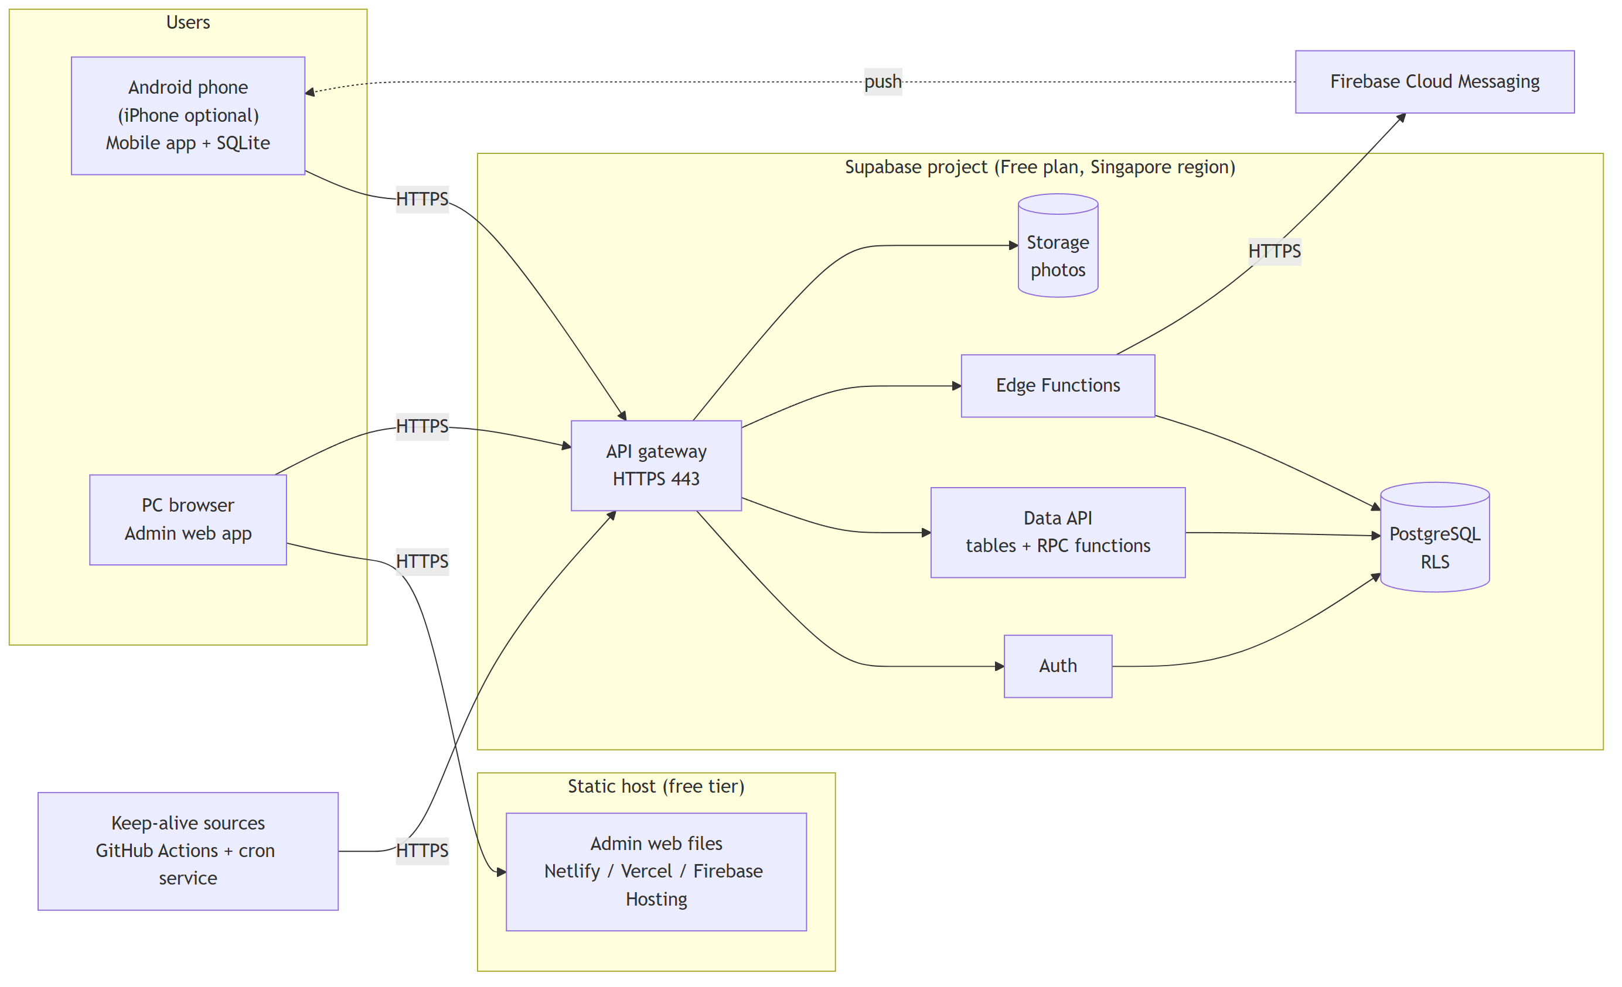
Figure 2. Production topology

2.2 Environments
Environment | Purpose | Backend | Clients
Dev | Development and tests | Supabase project ojt-dtr-dev | Browser, debug APK, emulator
Prod | Demonstration and user acceptance test | Supabase project ojt-dtr-prod | Release APK, admin web URL
Local (optional) | Clean tests and rebuild drill | Supabase CLI + Docker on a laptop | Browser, emulator

2.3 Components
Component | Function | Service
Admin web app | Static files of the Angular web build | Netlify, Vercel, or Firebase Hosting
Auth | Login, sessions, token refresh | Supabase Auth
Data API | Table access and RPC calls (sync_push, sync_pull, heartbeat) | Supabase Data API
Database | PostgreSQL with RLS, functions, triggers | Supabase PostgreSQL
Storage | Photos and attachments (private buckets) | Supabase Storage
Edge Functions | Push messages, admin account actions, CSV export | Supabase Edge Functions
Push service | Push messages to phones | Firebase Cloud Messaging
Keep-alive and backups | Daily heartbeat calls, weekly backup | GitHub Actions, external cron service

2.4 Network flows
# | From | To | Protocol and port | Purpose
F1 | Mobile app | Supabase gateway | HTTPS 443 | Login, sync, photo upload
F2 | Admin browser | Static host | HTTPS 443 | Load the admin web app
F3 | Admin browser | Supabase gateway | HTTPS 443 | Admin data, Edge Functions
F4 | Edge Functions | FCM | HTTPS 443 | Send push messages
F5 | FCM | Mobile device | OS push channel | Deliver push messages
F6 | GitHub Actions, cron service | Supabase gateway | HTTPS 443 | Heartbeat (keep-alive)
F7 | GitHub Actions | Supabase session pooler | PostgreSQL/TLS 5432 | Weekly backup
F8 | Developer laptop | Supabase | HTTPS 443, 5432 | Migrations and deploys

2.5 Security controls
Control | Implementation
Encryption in transit | HTTPS (TLS 1.2 or later) for all traffic
Authentication | Supabase Auth. Token life 15 minutes. Refresh token rotation. Public sign-up off.
Authorization | RLS rules on each table. OJT sees own data. Facilitator sees assigned OJTs only.
Login attempts | Supabase Auth sign-in rate limit
Secrets | Service role key and other secrets only in Edge Function secrets and GitHub secrets. Never in the apps.
Backups | Weekly encrypted own backup

2.6 Free plan limits and protection
Limit | Value | Control
Pause for low activity | After 7 days | Three protection layers (below)
Automatic backups | Not included | Weekly encrypted own backup
Database | 500 MB | Enough for one term. Weekly size check.
File storage / egress | 1 GB / 5 GB | Photos 500 KB or less, thumbnails, selfie off by default
Active projects | 2 | dev and prod only

Layer | Measures
1. Prevention | Daily heartbeat from GitHub Actions and from a cron service. Developer opens the apps two times each week. Supabase warning email goes to a read inbox.
2. Tolerance | Apps keep working offline. "Server not reachable" message. No forced sign-out. No data loss.
3. Recovery | Resume a paused project in 30 minutes or less. Rebuild from git and the newest backup in 2 hours or less. Phones send their last 30 days of records again.

2.7 Development network
Phones, the emulator, and the laptop connect to the dev project over HTTPS. A LAN connection between the phone and the laptop is not necessary.

3. Test Plan

3.1 Approach: bottom-up
The team tests the lowest layers first, then adds one layer at a time up to the full system.
- The highest risk is in the low layers: the local database, the outbox, and the sync engine.
- All mobile modules depend on the sync engine and the DTR module. Faults there must be found early.
- The test order agrees with the build order. A UI prototype walkthrough in stage S0 covers the early UI check.
Layer | Contents | Test level
0 | Utilities: hours calculation, validation, IDs | Unit
1 | Data access: PostgreSQL tables and RLS; SQLite adapter | Unit, component integration
2 | Services: database functions, outbox, sync engine, repositories | Unit, component integration
3 | Interfaces: Data API, RPC, Edge Functions, route guards | Component integration
4 | UI pages for each feature | Component, subsystem integration
5 | Full system on devices, web, and cloud | System, acceptance

3.2 Test levels
Level | Purpose | Tools
L1 Unit (U) | Each function is correct alone | Vitest, Angular test runner
L2 Component integration (CI) | Units work together. RLS and functions obey the access rules. | Vitest + supabase-js, SQLite test adapter
L3 Subsystem integration (SI) | App and backend work together on a real device and network | Android phone and emulator, fault injector
L4 System (ST) | Full system meets functional and quality requirements | Playwright, devices, load test, security advisor, accessibility tools
L5 Acceptance (UAT) | Real users can do their work | User scripts, SUS form

3.3 Network conditions for offline tests
Code | Condition
N1 | Online, stable
N2 | Offline (airplane mode)
N3 | Offline to online during work
N4 | Online to offline during a sync
N5 | Slow network
N6 | Network up, backend down or paused
N7 | Session expired while offline

3.4 Stage gates
Stage | Dates | Main tests | Exit criteria
S0 Plan and design | Oct 21 to 27 | Requirement review, design review, UI walkthrough | Reviews closed. Test plan accepted.
S1 Foundation | Oct 28 to Nov 3 | Auth, RLS access, local database, plugin smoke test | Login works for each role. Keep-alive and backups active.
S2 Offline core | Nov 4 to 10 | DTR, sync, network fault, app stop, backend down | Zero data loss. No forced sign-out.
S3 Reports and admin | Nov 11 to 17 | Report and correction cycles on two devices, admin functions | Access rules pass 100%.
S4 Completion and quality | Nov 18 to 24 | All system tests, ISO/IEC 25010 tests, pause and rebuild drills | Each quality target measured.
S5 Release | Nov 25 to 28 | Full regression, user acceptance, production smoke test | All "Must" functions pass. Zero open S1 and S2 defects.

Each gate also needs: all planned tests run, zero lint errors, regression suites pass, and a stage test report.

3.5 Defect severity
Severity | Meaning
S1 Critical | Data loss, security breach, or crash in a core flow. No workaround.
S2 Major | A "Must" requirement fails. Workaround is difficult.
S3 Minor | A function fails. An easy workaround exists.
S4 Trivial | Text, layout, or color problem

